

SITAM
SATYA INSTITUTE OF TECHNOLOGY AND MANAGEMENT
Gajularega, Vizianagaram, Andhra Pradesh, India-535002.
Accredited by "NAAC"
Approved by AICTE and Affiliated to JNTUK, KAKINADA
Email: sitam@sitam.co.in, Website:www.sitam.co.in
Telephone No:9676788811, 8978812341/2, Land Line: 08922-234775

4.1.3 Number of Classrooms and Seminar Halls With ICT- Enabled Facilities Such as Smart Class, LMS, Etc.
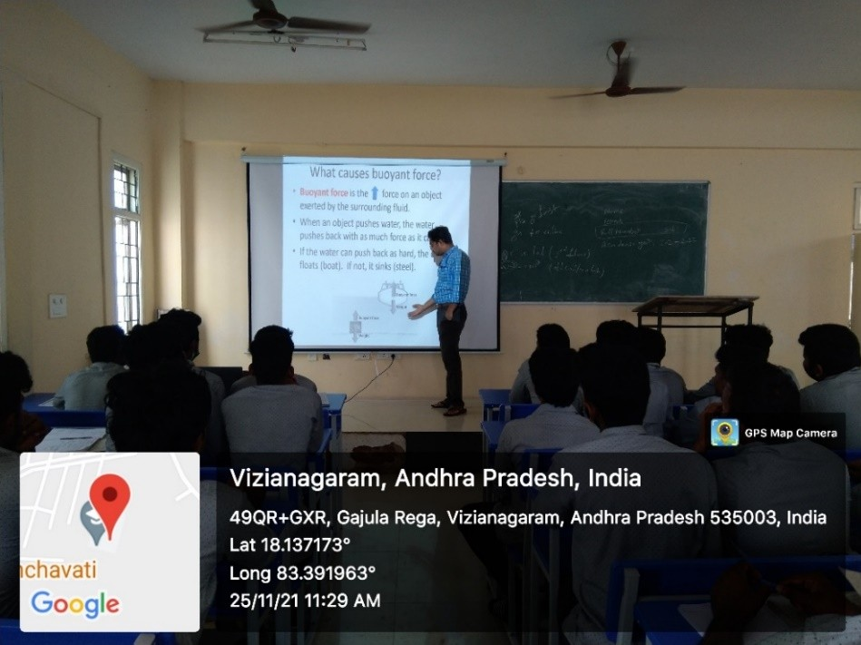

MECH CLASS ROOM A 201
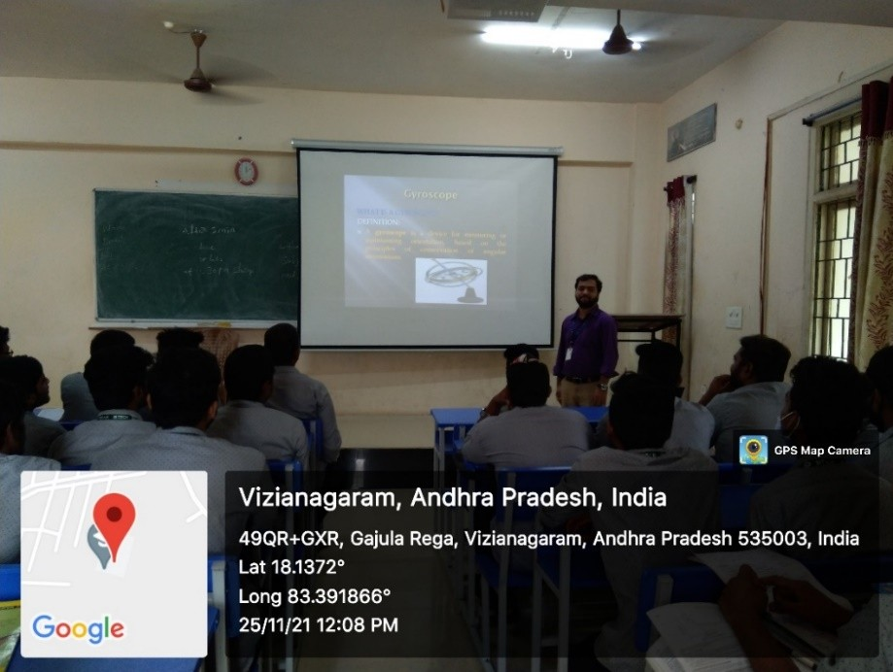

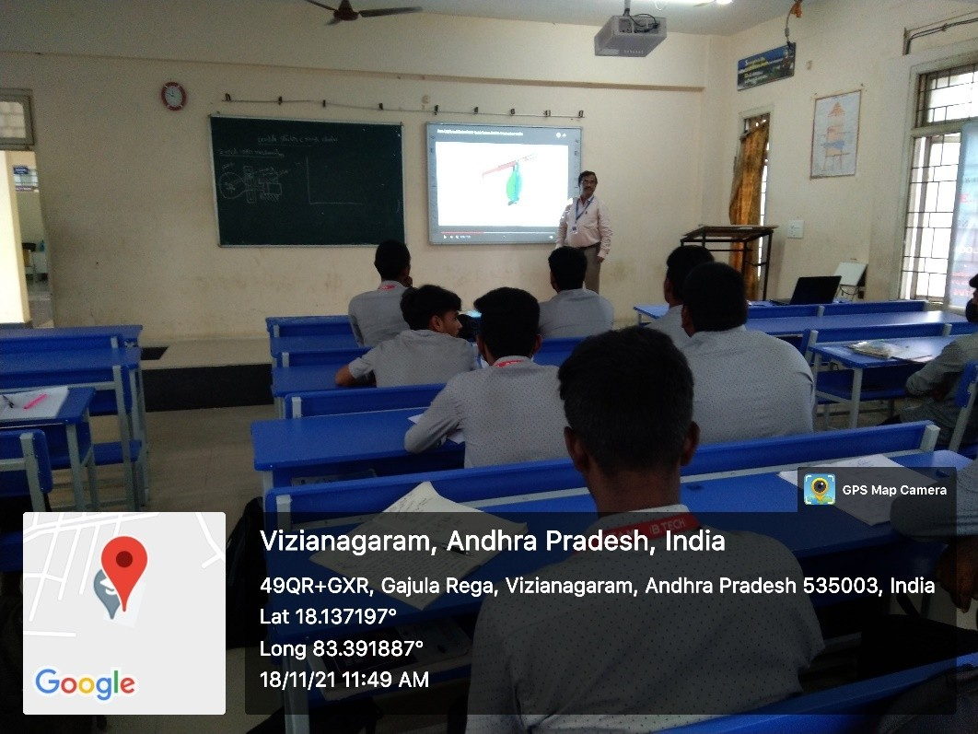

MECH CLASS ROOM A 205

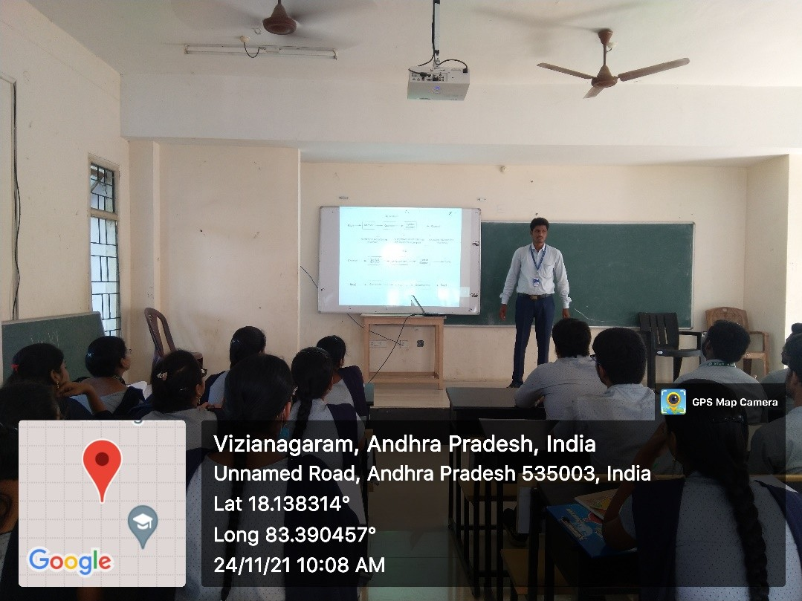

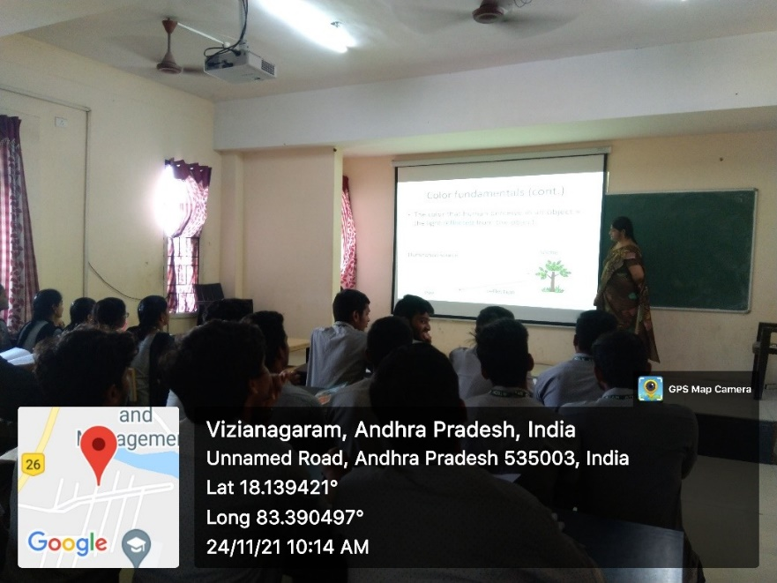

ECE CLASS ROOM D 203

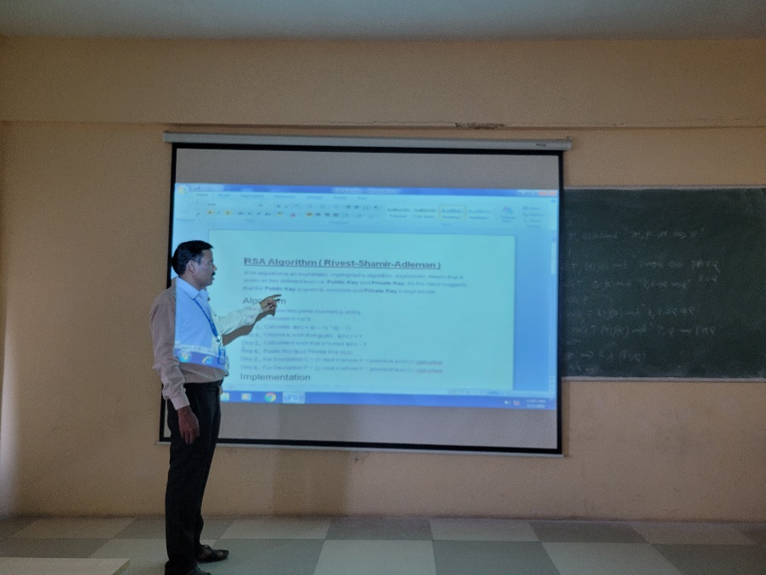

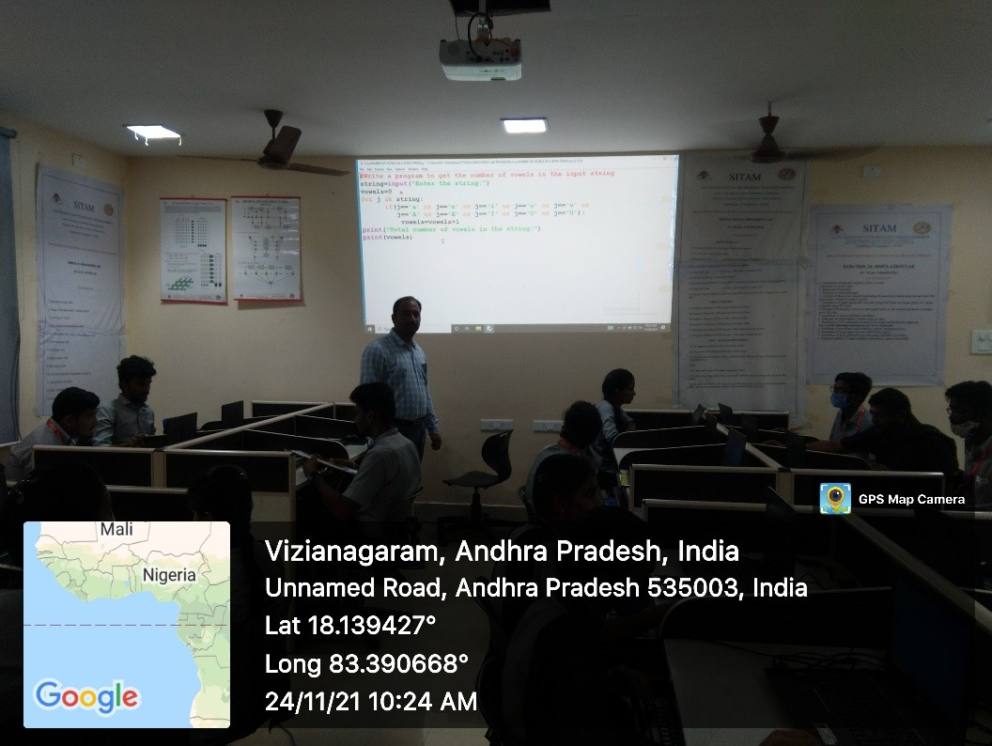

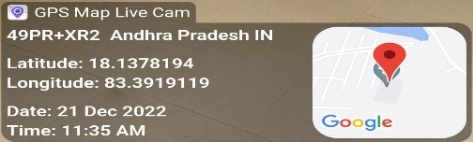

CSE CLASS ROOM D 403

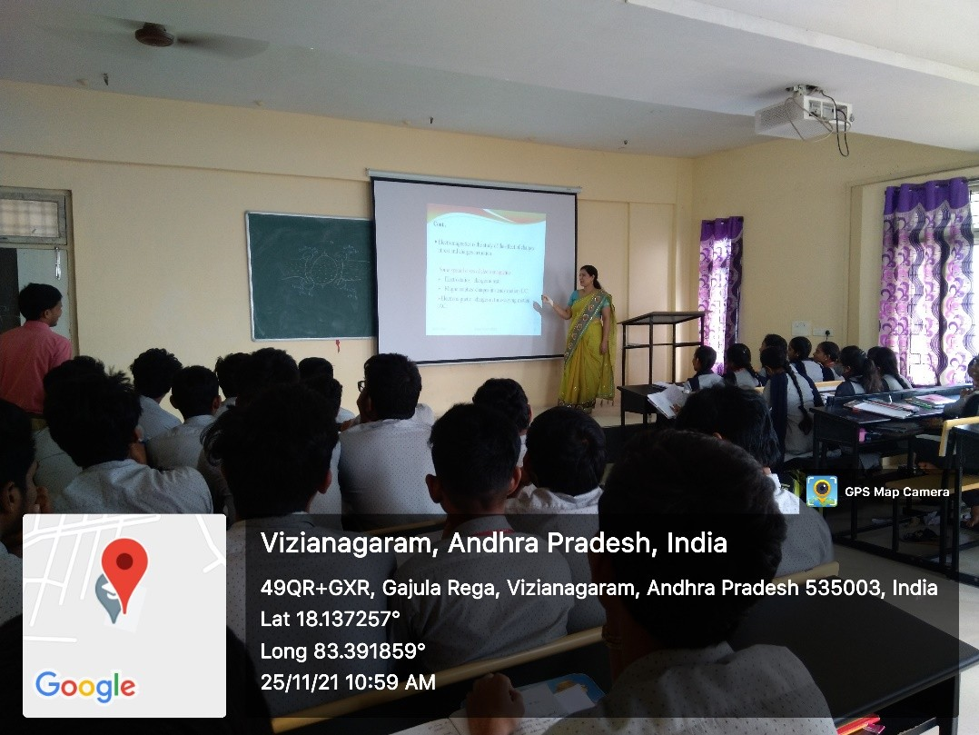

EEE CLASS ROOM A 403

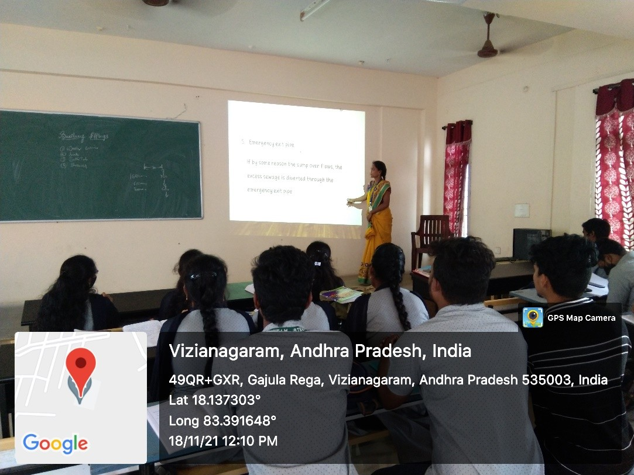

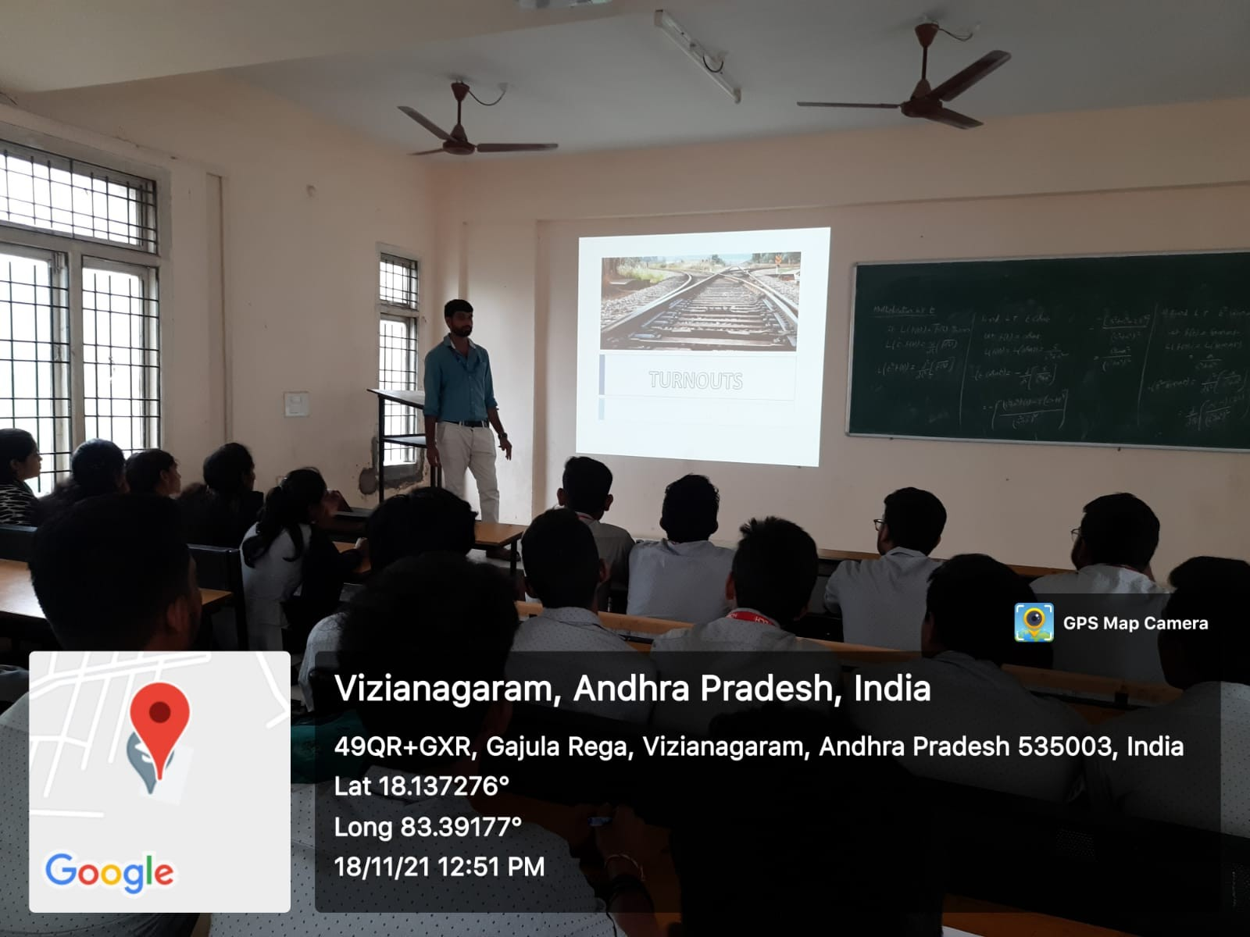

CIVIL CLASS ROOM B 405

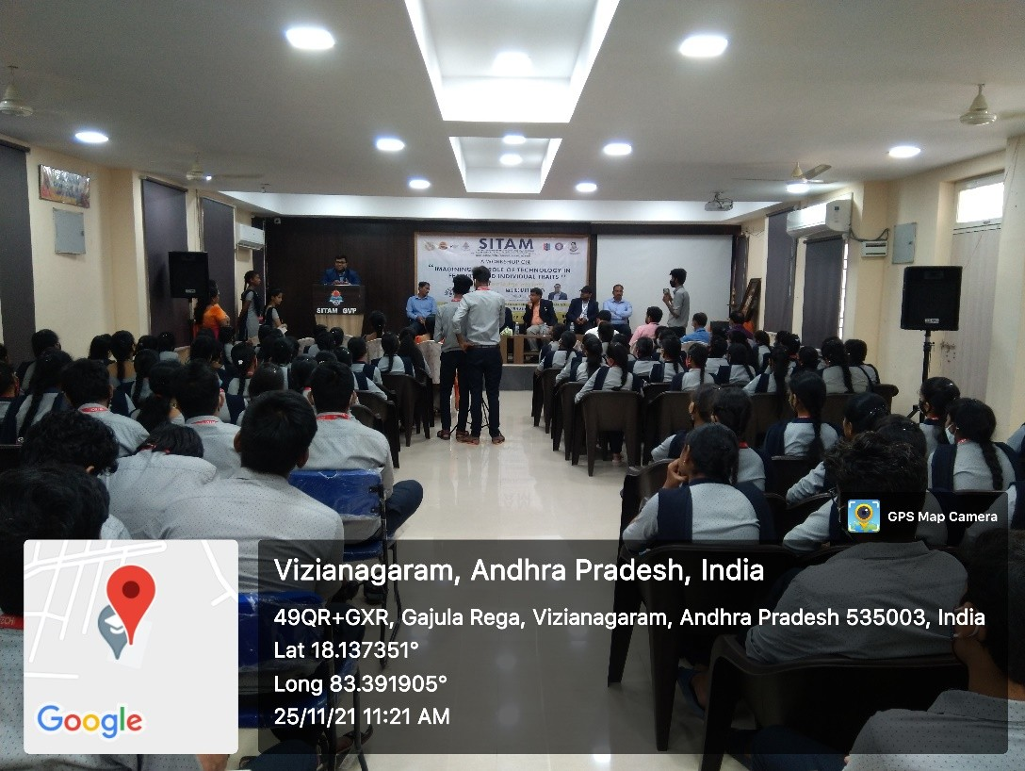

SEMINAR HALL F 202

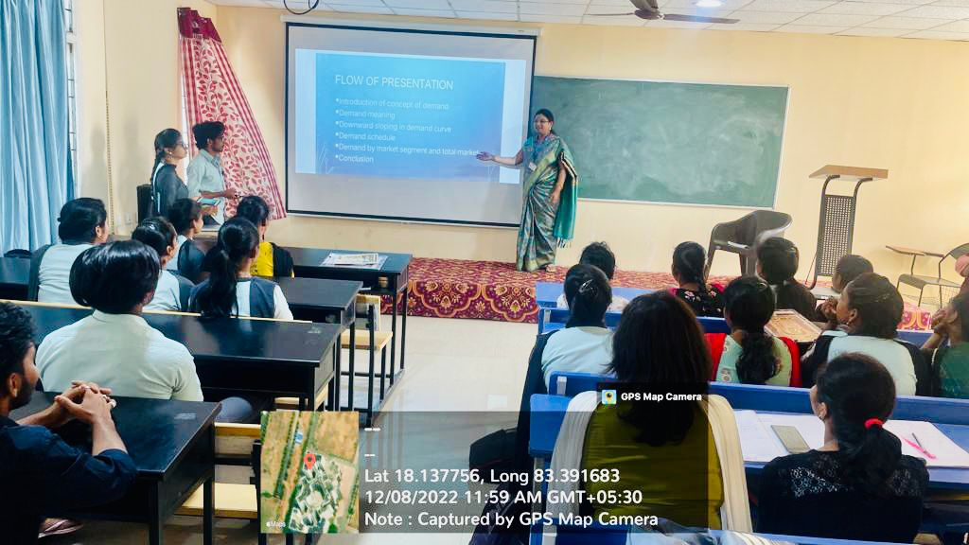

MBA CLASS ROOM D 302

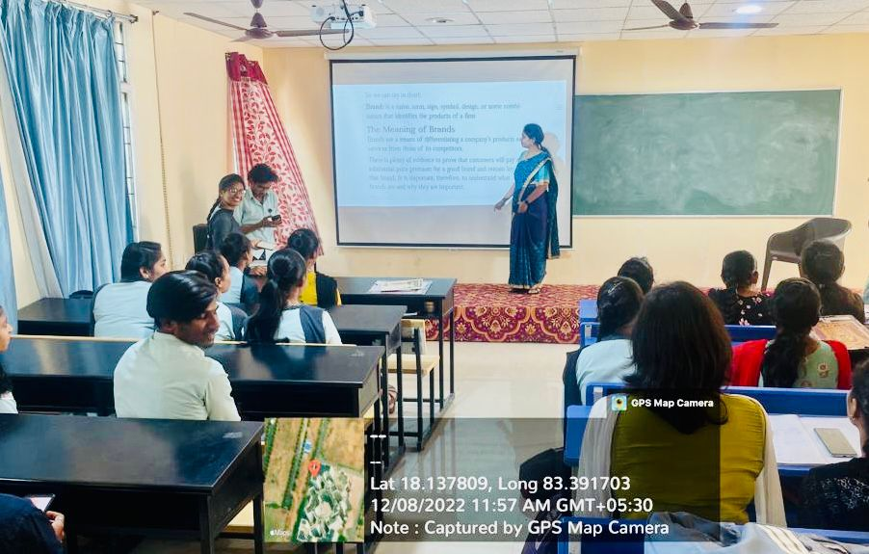

MBA SEMINAR HALL D 305

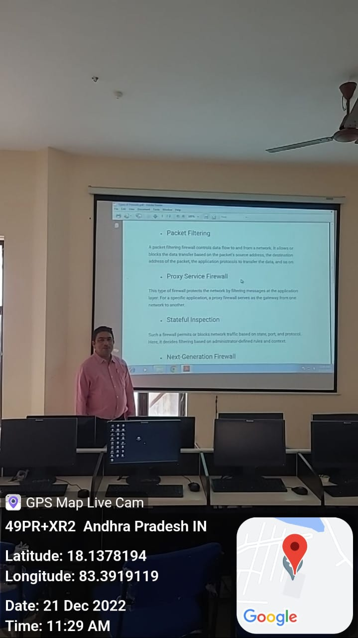
CSE COMPUTER LAB 3 F 401

